WEEK 4 – INTERNSHIP FINAL WORK REPORT
Airline Passenger Satisfaction Analysis Using R
Internship Project: Airline Passenger Satisfaction Analysis
Internship Area: Data Analytics
Tools Used: R, RStudio, ggplot2 and statistical modelling techniques
Dataset: Airline Passenger Satisfaction Dataset
Internship Period: Four Weeks
1. Project Overview
The main objective of this internship project was to analyse airline passenger satisfaction using data analytics techniques in R. The project focused on understanding passenger behaviour, identifying the factors that influence customer satisfaction, visualising important patterns in the dataset, and developing a logistic regression model to predict whether a passenger is satisfied or neutral/dissatisfied.
The work was completed in different stages over the internship period. The first stage involved data cleaning and preprocessing. The second stage focused on data visualisation and identifying useful patterns. The third stage involved developing and evaluating logistic regression models. In Week 4, the work from all three stages was reviewed, compared and combined to understand the overall results.
The project helped demonstrate how raw airline customer data can be converted into meaningful information that can support business decisions and improve passenger experience.
2. Objectives of the Internship Project
The main objectives were:
- To understand and explore the Airline Passenger Satisfaction dataset.
- To identify and handle missing values and duplicate records.
- To detect possible outliers in numerical variables.
- To clean and prepare the dataset for analysis.
- To perform exploratory data analysis using R.
- To create visualisations to understand passenger satisfaction patterns.
- To identify relationships between passenger-related variables.
- To develop a logistic regression model for satisfaction prediction.
- To compare two logistic regression models and evaluate their performance.
- To combine the findings from all three weeks and identify important factors affecting passenger satisfaction.
3. Dataset Description
The Airline Passenger Satisfaction dataset was used for the analysis.
The dataset contained 103,904 observations and 25 original variables. It included information about passengers, their travel details, airline services and satisfaction levels.
Important variables included:
- Gender
- Age
- Customer Type
- Type of Travel
- Class
- Flight Distance
- Inflight Wi-Fi Service
- Online Boarding
- Seat Comfort
- Inflight Entertainment
- Cleanliness
- Departure Delay in Minutes
- Arrival Delay in Minutes
- Satisfaction
The target variable was passenger satisfaction. It was divided into two categories:
- Satisfied
- Neutral or Dissatisfied
This dataset provided an opportunity to understand which passenger characteristics and airline services were associated with satisfaction.
4. Week 1 – Data Cleaning and Preliminary Analysis
Tasks Completed
The first week focused on understanding the dataset and preparing it for further analysis.
The following tasks were completed:
- Imported the dataset into RStudio.
- Checked the dataset structure and dimensions.
- Examined variable names and data types.
- Identified missing values.
- Checked for duplicate records.
- Analysed numerical variables.
- Detected potential outliers using boxplots and the Interquartile Range (IQR) method.
- Handled missing values.
- Normalised selected numerical variables.
- Encoded categorical variables for further analysis.
Missing Value Analysis
The initial analysis identified 310 missing values in the arrival delay in minutes variable.
Mean imputation was used to handle the missing values. After preprocessing, no missing values remained in the dataset.
Duplicate Record Analysis
The dataset was checked for duplicate records.
Result: No duplicate records were identified.
Outlier Detection
The IQR method was used to identify potential outliers in numerical variables.
The analysis identified the following potential outlier counts:
Variable | Potential Outliers
Age | 0
Flight Distance | 2,291
Arrival Delay | 13,954
For arrival delay, the calculated values were:
- First quartile (Q1): 0
- Third quartile (Q3): 13
- IQR: 13
- Lower limit: -19.5
- Upper limit: 32.5
The identified outliers were retained because they could represent genuine airline operational situations, such as long flight delays or unusual flight distances. Removing them without further investigation could result in the loss of useful information.
Data Transformation
Min-Max normalisation was applied to selected numerical variables:
- Age
- Flight Distance
- Arrival Delay in Minutes
Categorical variables were also encoded into numerical values.
Variable | Encoding
Gender | Female = 0, Male = 1
Customer Type | Disloyal = 0, Loyal = 1
Type of Travel | Personal = 0, Business = 1
Class | Eco = 0, Eco Plus = 1, Business = 2
Satisfaction | Neutral/Dissatisfied = 0, Satisfied = 1
Week 1 Outcome
The first week successfully prepared the dataset for further analysis. Missing values were handled, duplicate records were checked, potential outliers were identified, and numerical and categorical variables were transformed.
This prepared dataset became the foundation for the visualisation and predictive modelling tasks completed in the following weeks.
5. Week 2 – Data Visualisation and Insight Communication Using R
Tasks Completed
The second week focused on exploratory data analysis and visualisation using R.
The ggplot2 package was used to create graphs that helped identify patterns, relationships and differences between passenger groups.
Eight visualisations were created.
1. Passenger Satisfaction Distribution
A bar chart was created to understand the distribution of passenger satisfaction.
Satisfaction Category | Number of Passengers
Satisfied | 45,025
Neutral/Dissatisfied | 58,879
Total | 103,904

Finding: The number of neutral or dissatisfied passengers was higher than the number of satisfied passengers. This indicated that there was considerable scope for improving the passenger experience.
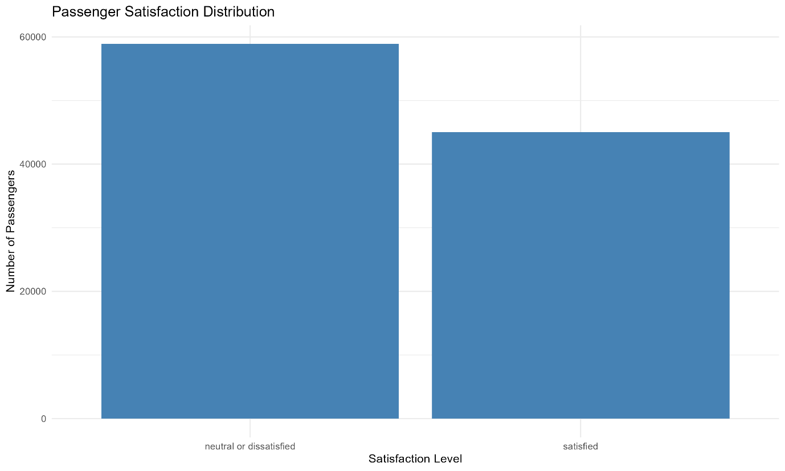
2. Age Distribution
A histogram was created using five-year age intervals.
Finding: The graph helped understand the age distribution of passengers and identify the age groups represented in the dataset.

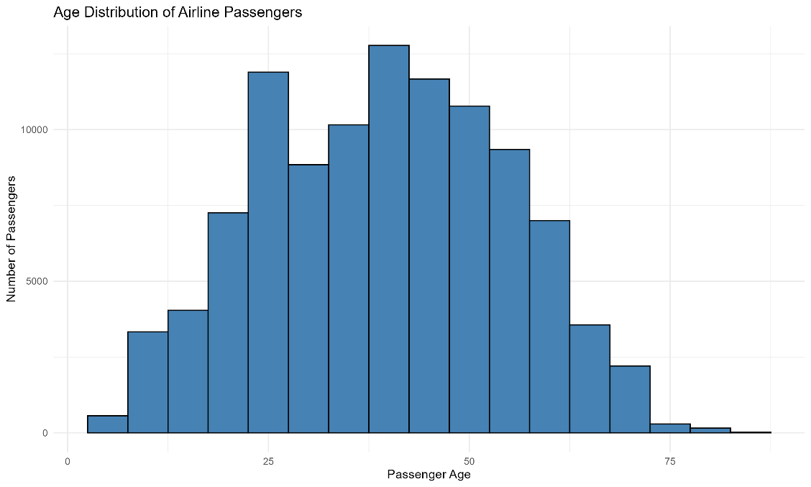

3. Flight Distance Distribution
A histogram was created using 200-unit flight distance intervals.
Finding: The visualisation showed how flight distances were distributed and helped identify the range of journeys represented in the dataset.

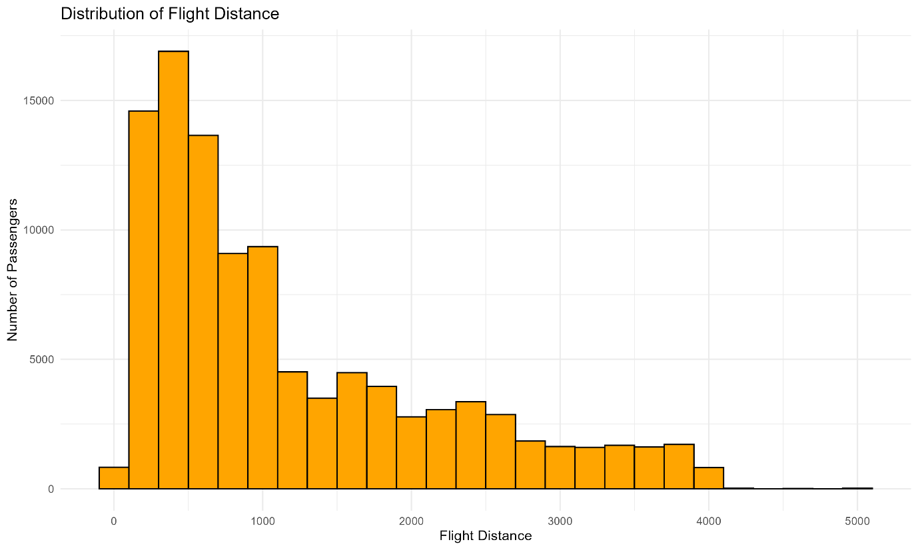

4. Customer Type and Satisfaction
A comparison graph was created to examine satisfaction among loyal and disloyal customers.
Finding: Customer type showed an important relationship with passenger satisfaction. This variable was also found to be statistically significant in the logistic regression analysis completed in Week 3.

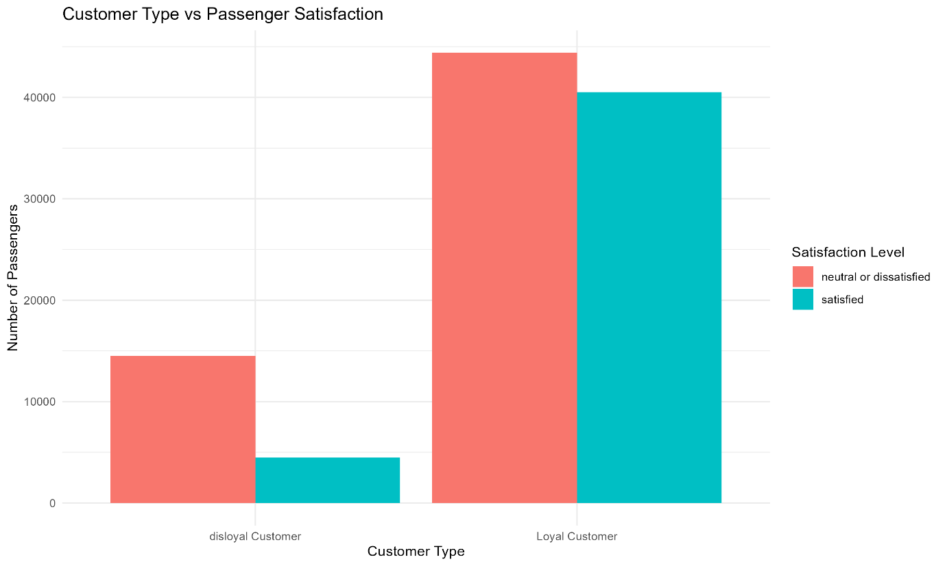
5. Flight Distance and Arrival Delay
A scatter plot was created to examine the relationship between flight distance and arrival delay.
Finding: The graph helped explore whether longer flight distances were associated with higher arrival delays. Flight distance was not found to be statistically significant in the final logistic regression model.

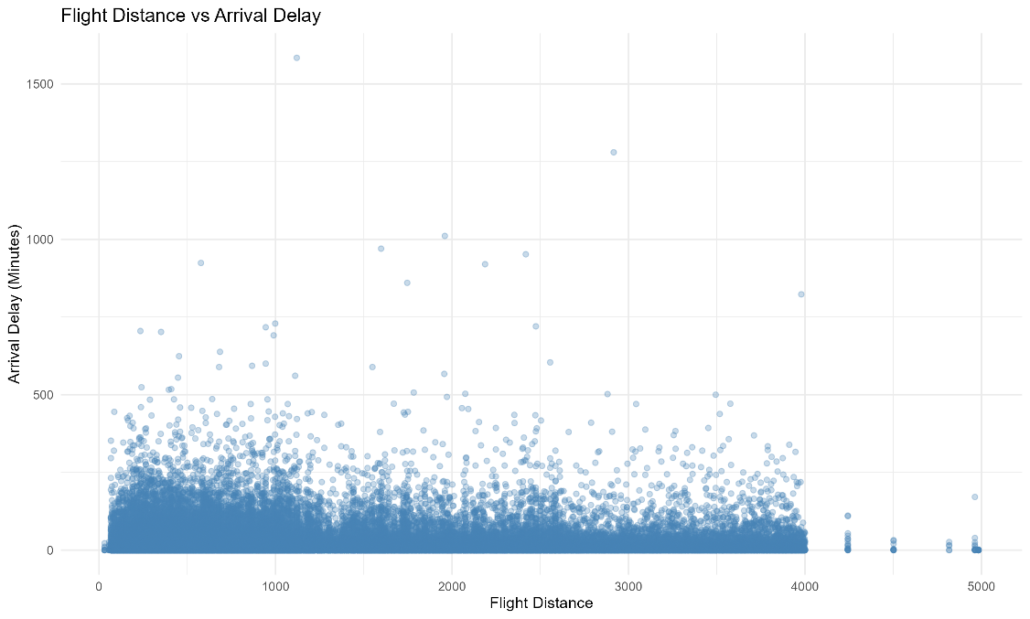

6. Average Arrival Delay by Age Group and Travel Type
A visualisation was created to compare average arrival delay across age groups and travel types.
Finding: This graph helped examine delay patterns across different passenger groups and provided a better understanding of operational differences.

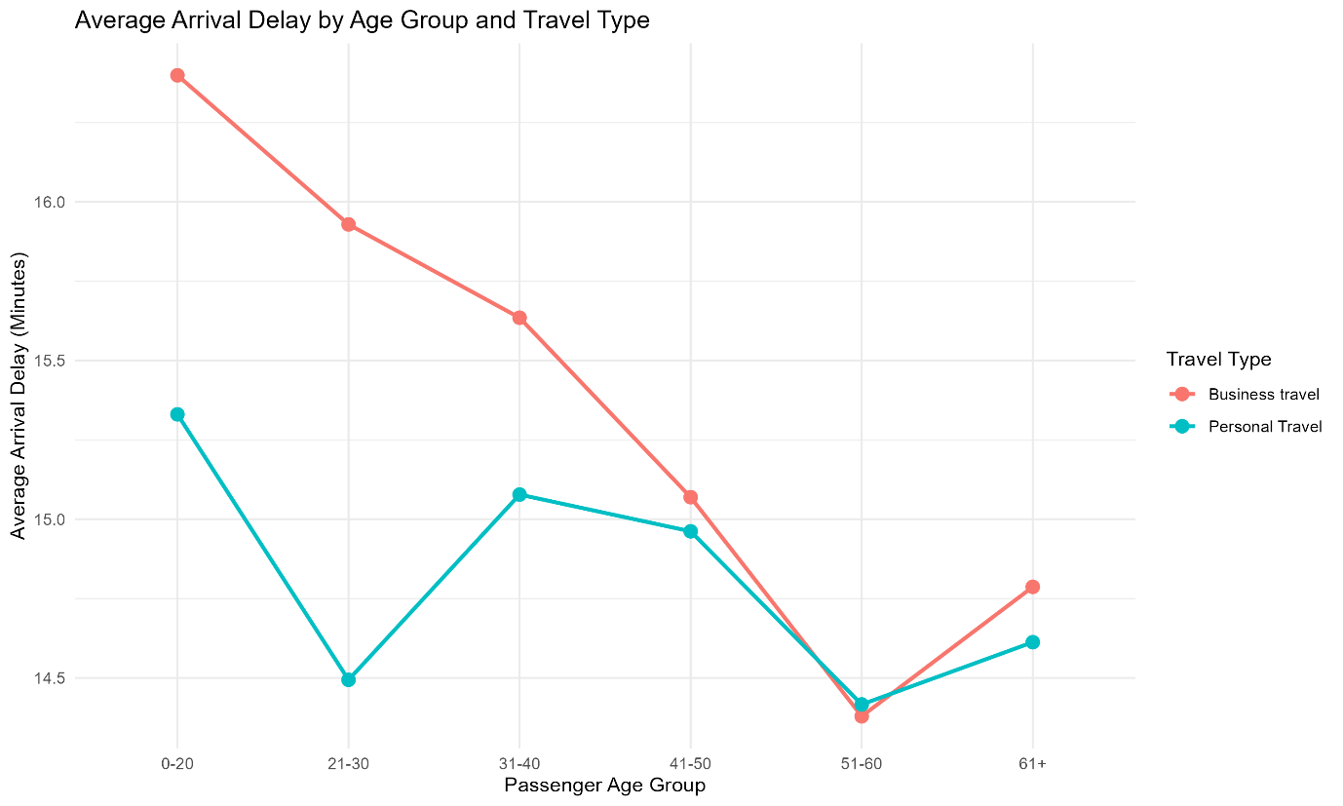

7. Satisfaction by Travel Class
A 100% stacked bar chart was created to compare passenger satisfaction across Business, Eco and Eco Plus classes.
Finding: Travel class was an important variable for understanding satisfaction differences. It was also statistically significant in the predictive modelling stage.
8. Correlation Heatmap
A correlation heatmap was created to examine relationships between numerical variables.
Important findings included:
- Departure delay and arrival delay had a strong positive correlation of approximately 0.96.
- Seat comfort and cleanliness had a positive correlation of approximately 0.68.
Finding: Departure delay and arrival delay were strongly related. This indicated a possible multicollinearity issue when both variables were included in the same regression model.
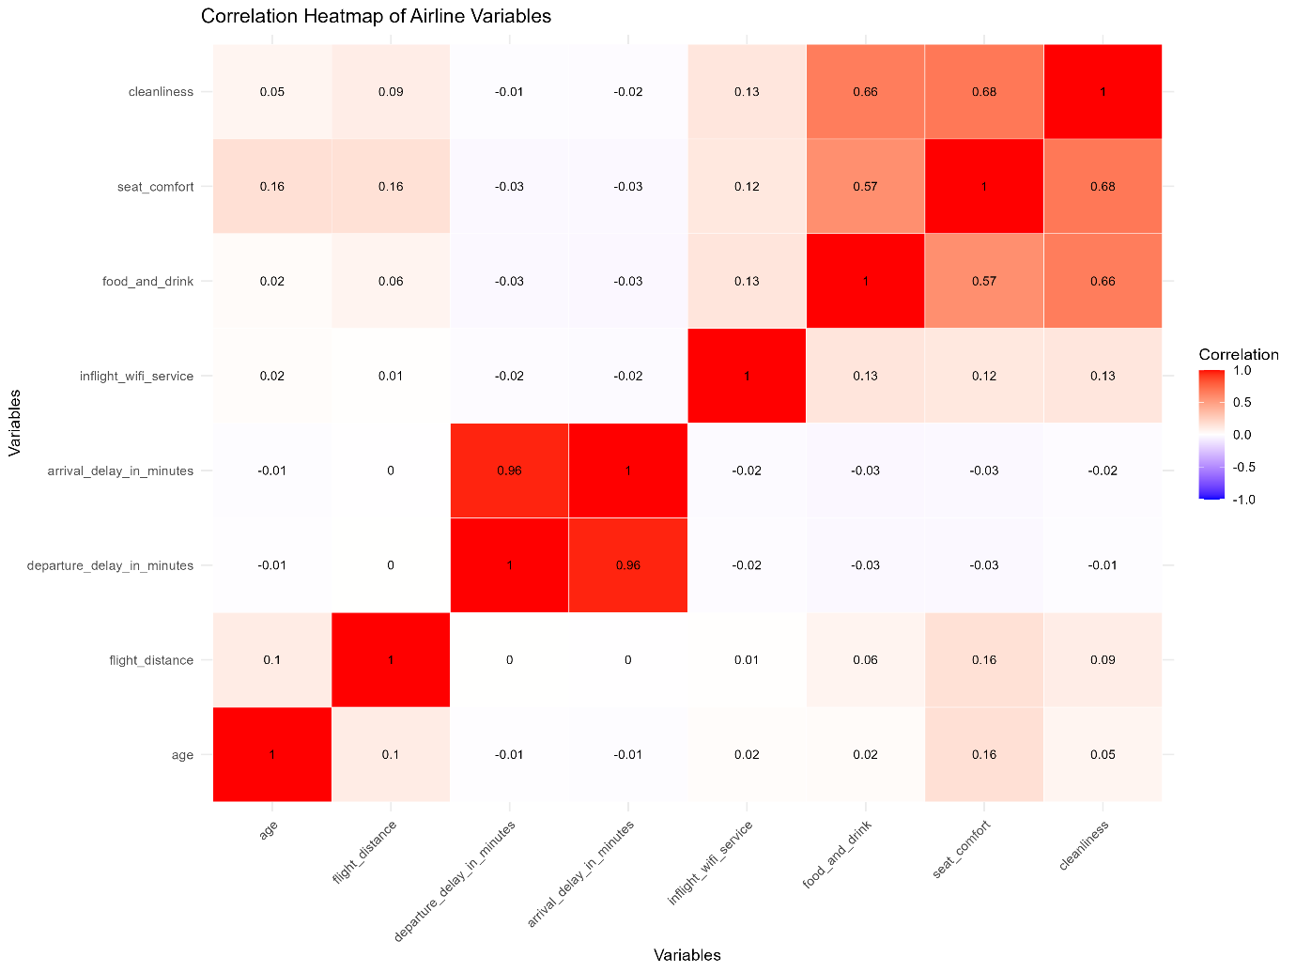

Week 2 Outcome
The second week transformed the cleaned dataset into visual information that was easier to understand and interpret.
The visualisations helped identify important variables and relationships that could be investigated further through statistical modelling.
6. Week 3 – Airline Passenger Satisfaction Prediction Using Logistic Regression
Tasks Completed
The third week focused on developing a predictive model using logistic regression.
The objective was to predict whether a passenger was satisfied or neutral/dissatisfied based on passenger information, travel details and airline service ratings.
Target Variable Preparation
The satisfaction variable was converted into a binary format:
- 1 = Satisfied
- 0 = Neutral/Dissatisfied
The dataset was divided into training and testing data. The test dataset contained 20,781 observations.
Model Development
Two logistic regression models were developed and compared.
Model 1: Logistic Regression with Departure and Arrival Delay
The first model included both departure delay and arrival delay.
However, the correlation analysis from Week 2 showed that these variables had a very strong positive correlation of approximately 0.96. This indicated a multicollinearity concern.
Model 2: Logistic Regression without Departure Delay
The second model excluded departure delay while retaining arrival delay.
This was done to reduce the multicollinearity problem and produce a more practical model.
The second model converged successfully, and the adjusted Variance Inflation Factor (VIF) values were below 2, indicating reduced multicollinearity among the model predictors.

Model Performance Comparison
The performance of both models was evaluated using accuracy, precision, recall, F1-score, AUC and AIC.
Evaluation Metric | Model 1 | Model 2
Accuracy | 85.79% | 85.86%
Precision | 84.54% | 84.65%
Recall | 82.49% | 82.51%
F1-Score | 83.50% | 83.57%
AUC | 0.9155 | 0.9155
AIC | 76,956.01 | 76,975.50
Model Comparison and Interpretation
The results showed that both models performed well.
Model 2 achieved slightly better accuracy, precision, recall and F1-score. Both models had the same AUC value of 0.9155, indicating strong ability to distinguish between the two satisfaction categories.
However, Model 1 had a lower AIC value. A lower AIC generally indicates a better balance between model fit and complexity when comparing models fitted to the same data.
Therefore, the model selection involved a trade-off:
- Model 1 had the lower AIC.
- Model 2 had slightly better test-set classification metrics.
- Model 2 reduced the multicollinearity concern by excluding departure delay.
Model 2 was considered the more practical choice for interpretation and prediction, while Model 1 remained useful for comparison because of its lower AIC.

Significant Variables
At the 5% significance level, the following variables were found to be statistically significant in Model 2:
- Age
- Customer Type
- Type of Travel
- Class
- Inflight Wi-Fi Service
- Online Boarding
- Inflight Entertainment
- Cleanliness
- Arrival Delay
The following variables were not statistically significant in Model 2:
- Gender
- Flight Distance
- Seat Comfort
Important Findings
The model indicated that:
- Loyal customer status had a positive relationship with satisfaction.
- Personal travel had a negative relationship with satisfaction relative to the business travel reference category.
- Eco and Eco Plus classes had negative relationships with satisfaction relative to the Business class reference category.
- Better online boarding ratings were positively associated with satisfaction.
- Better inflight entertainment ratings were positively associated with satisfaction.
- Higher arrival delays had a negative relationship with satisfaction.
These findings indicated that customer loyalty, travel type, class, airline services and flight delays were important factors to consider when analysing passenger satisfaction.
Cross-Validation Results
Five-fold cross-validation was also performed.
The reported results were:
Metric | Result
RMSE | 0.3287
R-squared | 0.5602
MAE | 0.2233
These regression-style measures were reported separately from the classification metrics because they evaluate model performance in a different way.
Influence Analysis
Cook's distance was used to examine influential observations.
A total of 7,217 observations were identified above the \(4/n\) threshold.
These observations were not automatically removed because influential points may contain important information. Further investigation would be required before deciding whether any observations should be excluded.
Week 3 Outcome
The third week successfully developed and evaluated two logistic regression models. The comparison demonstrated that the model without departure delay provided slightly better classification metrics while reducing the multicollinearity concern.
The analysis also identified important passenger and service-related factors associated with satisfaction.
7. Week 4 – Overall Comparison and Integration of Previous Work
Purpose of Week 4
The fourth week focused on reviewing, comparing and integrating all the tasks completed during the previous three weeks.
Instead of treating data cleaning, visualisation and prediction as separate activities, the objective was to understand how each stage contributed to the final analysis.
Comparison of All Four Weeks
Week | Main Task | Work Completed | Main Outcome
Week 1 | Data Cleaning and Preliminary Analysis | Missing values, duplicates, outliers, normalisation and encoding | Prepared dataset
Week 2 | Data Visualisation and Insight Communication | Eight visualisations and correlation analysis | Identified patterns and relationships
Week 3 | Logistic Regression Prediction | Developed and compared two models | Achieved approximately 85.86% accuracy in Model 2
Week 4 | Final Analysis and Comparison | Reviewed all results and combined findings | Overall interpretation and business recommendations
How the Three Stages Were Connected
Week 1 to Week 2:
Data cleaning provided a reliable dataset for visualisation. Without handling missing values and preparing the variables, the graphs and analysis could have been affected by incomplete or incorrectly formatted data.
Week 2 to Week 3:
The visualisations helped identify important relationships between variables. In particular, the correlation heatmap identified the strong relationship between departure delay and arrival delay. This helped explain why departure delay was removed from Model 2.
Week 3 to Week 4:
The logistic regression models provided measurable results about prediction performance and statistically significant variables. These results were combined with the earlier visual findings to produce a more complete understanding of passenger satisfaction.
Overall Comparison of Key Findings
Area of Analysis | Finding | Importance
Passenger satisfaction | 58,879 passengers were neutral/dissatisfied | Indicates scope for improvement
Customer type | Customer type was statistically significant | Loyalty is important in satisfaction analysis
Travel type | Type of travel was statistically significant | Satisfaction differs by travel purpose
Travel class | Class was statistically significant | Passenger class is relevant to satisfaction
Online boarding | Statistically significant | Digital services are important
Inflight entertainment | Statistically significant | Onboard experience matters
Cleanliness | Statistically significant | Cabin service quality matters
Arrival delay | Statistically significant with a negative relationship | Delays can reduce satisfaction
Gender | Not statistically significant in Model 2 | Limited predictive contribution in this model
Flight distance | Not statistically significant in Model 2 | Limited predictive contribution in this model
Seat comfort | Not statistically significant in Model 2 | Not independently significant in this model
8. Overall Business Insights
The combined analysis provided several useful insights for the airline industry.
1. Improve Online Boarding Services
Online boarding was statistically significant and positively associated with passenger satisfaction. Airlines should focus on making online check-in and boarding processes simple, reliable and convenient.
2. Improve Inflight Entertainment
Inflight entertainment was positively associated with satisfaction. Providing reliable entertainment options may help improve the passenger experience.
3. Focus on Cabin Cleanliness
Cleanliness was statistically significant in the model. Airlines should maintain proper cleaning standards and regularly monitor cabin hygiene.
4. Reduce Arrival Delays
Arrival delay had a negative relationship with passenger satisfaction. Improving scheduling, operational coordination and delay communication may help reduce passenger dissatisfaction.
5. Strengthen Customer Loyalty
Customer type was statistically significant, and loyal customer status had a positive relationship with satisfaction. Airlines can focus on customer retention, loyalty programmes and consistent service quality.
6. Review Travel Class Experience
Class was statistically significant. Airlines should regularly review the service quality and facilities provided across Business, Eco and Eco Plus classes.
These recommendations are based on the relationships identified in the dataset and model. They should be treated as areas for further business investigation rather than proof that any single change will directly cause satisfaction to increase.
9. Challenges Faced During the Internship
During the project, several analytical challenges were identified.
Missing Values: The arrival delay variable contained 310 missing values, which required preprocessing.
Outliers: A considerable number of potential outliers were identified in arrival delay. These values required careful consideration because they could represent genuine operational events.
Data Transformation: Categorical variables needed to be encoded before they could be used in the predictive model.
Data Visualisation: Different types of graphs were required to understand the distribution of data and relationships between variables.
Multicollinearity: Departure delay and arrival delay had a strong correlation of approximately 0.96. This required comparing models with and without departure delay.
Model Evaluation: Selecting a model required considering multiple evaluation metrics rather than relying only on accuracy.
Influential Observations: Cook's distance identified observations that required further investigation.
10. Skills and Knowledge Gained
Through the four-week internship project, the following skills and knowledge were developed:
- Understanding real-world datasets.
- Data cleaning and preprocessing using R.
- Missing value handling.
- Duplicate record checking.
- Outlier detection using the IQR method.
- Numerical data normalisation.
- Categorical variable encoding.
- Exploratory data analysis.
- Data visualisation using ggplot2.
- Correlation analysis.
- Logistic regression modelling.
- Multicollinearity analysis using VIF.
- Model evaluation using accuracy, precision, recall, F1-score and AUC.
- Cross-validation.
- Interpretation of statistical significance.
- Communicating analytical findings.
- Comparing multiple analytical approaches.
11. Limitations and Future Improvements
Although the project produced useful findings, some limitations should be considered.
- Mean imputation was used for missing arrival delay values. Other imputation methods could be compared in future work.
- Potential outliers were retained, but further investigation could help identify unusual operational cases.
- The analysis used logistic regression. Other classification algorithms could be tested for comparison.
- The model results show statistical relationships and predictive performance, not direct cause-and-effect relationships.
- Additional evaluation could examine model performance separately across passenger groups.
- Further investigation of influential observations could help understand their effect on model estimates.
- More recent airline passenger data could be used to check whether the findings remain consistent over time.
12. Final Conclusion
The four-week internship project successfully completed the major stages of an airline passenger satisfaction data analytics workflow.
During Week 1, the dataset was cleaned and prepared by handling missing values, checking duplicates, identifying potential outliers, normalising numerical variables and encoding categorical variables.
During Week 2, eight visualisations were developed using R and ggplot2. These visualisations helped understand passenger satisfaction, customer types, travel classes, flight distances, arrival delays and correlations between variables.
During Week 3, two logistic regression models were developed and compared. Model 2 achieved 85.86% accuracy, 84.65% precision, 82.51% recall, an F1-score of 83.57% and an AUC of 0.9155. It also reduced the multicollinearity concern by excluding departure delay. Model 1 had a lower AIC, so the comparison demonstrated the importance of evaluating models using multiple criteria.
During Week 4, the results from the previous stages were reviewed and integrated. The overall analysis identified customer type, travel type, class, online boarding, inflight entertainment, cleanliness and arrival delay as important variables associated with passenger satisfaction.
The project demonstrated how data cleaning, visualisation and predictive modelling can be combined to extract useful insights from real-world airline data. It also provided practical experience in using R for data analysis and statistical modelling.
Overall, the internship project improved my understanding of the complete data analytics process, from raw data preparation to visual interpretation, predictive modelling and business-oriented recommendations.

